**From:** Laura Coale [<mailto:laura.coale@aims.edu>]   
**Sent:** Wednesday, January 13, 2016 3:20 PM  
**To:** Brandon Dooling <[bdooling@gtc1.net](mailto:bdooling@gtc1.net)>  
**Subject:** Fwd: NEWS RELEASE: Aims Community College’s Public Safety Institute in Windsor Opens for Classes on January 19

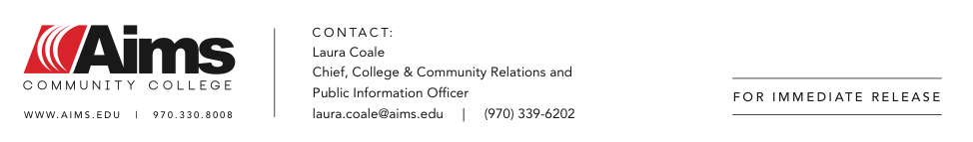

​**Aims Community College’s Public Safety Institute in Windsor**

**Opens for Classes on January 19**

**Holds Ribbon-Cutting and Open House**

GREELEY, CO – Jan. 13, 2016 –  Aims Community College today is pleased to announce the area’s premier state-of-the-art [Public Safety Institute](http://www.aims.edu/campus/windsor/psi) (PSI) in Windsor will open for classes on January 19 at 1130 South Gate Drive, adjacent to the college’s automotive and technology center. Dr. Leah L. Bornstein, president of Aims Community College; Carol Ruckel, Aims board chair; John Vazquez, mayor or Windsor; Deb Kish, dean of Allied Health programs, Academic Assessment, Automotive, Aviation, Criminal Justice, EMS, the Faculty Teaching & Learning, Fire Science, and Physical and Life Sciences; and Michael Millsapps, chief facilities management officer, spoke at a ribbon-cutting ceremony today. Immediately following the ceremony, tours were available of the facility and state-of-the-art training equipment during an open house until 1 p.m.

"Aims' new Public Safety Institute is extremely important for Windsor because it offers higher education learning opportunities in general education and public safety for residents and others traveling to Windsor," Windsor Mayor John Vazquez said. "I've been involved in this project from the time it was only an idea, and it is very rewarding to see such a beautiful campus completed and ready for students to receive world-class training."

The new 10-acre Public Safety Institute in Windsor houses Emergency Medical Services (EMS), Fire Science, Medical Assisting, Phlebotomy and Criminal Justice (CJ) (CJ classes start in the Summer 2016). Amenities include a 53,000 square-foot, two story, state-of-the-art building, drill ground area for fire, police and EMS training, training tower, science lab, smart classrooms, computer rooms, CPAT (Candidate Physical Ability Test) testing, student services (registration, Accuplacer testing, advising, tutoring), simulation rooms for paramedic and EMT training, workout room for physical fitness training, medical assistant lab with exam rooms, locker rooms, and general education offerings so students complete their degree requirement on site. The facility will also house a sand table used for fire modeling and planning and the first anatomage table in the state of Colorado, which is a virtual 4D cadaver resembling an operating table that has ability to load data from real-life patient or cadaver x-rays, CT scans, MRI scans and nuclear scans.

“Nationally, Aims’ Public Safety Institute will rank among the top in offering an inclusive education in public safety disciplines such as fire, EMS, medical assisting, phlebotomy and criminal justice,” said Dr. Leah L. Bornstein, president of Aims Community College. “We will focus on the student by providing active, hands-on simulations along with classroom study. This facility is truly unique to the Denver metro area, and we are looking forward to continuing our partnerships with emergency response agencies in Windsor and throughout Colorado.”

Additionally, the large open area between the fire training tower and classroom facility will include streets for emergency response training in apparatus and areas for training props. One of the training props will include a wildland area, including a pond for drafting evolutions. The master plan of the campus site includes a future simulated city block that will include mock residential and commercial buildings used for Criminal Justice, EMS and fire training.

Aims’ Public Safety Institute was designed by Denver-based [AndersonMasonDale](http://www.amdarchitects.com/) Architects and the general contractor was [Golden Triangle Construction](http://www.gtc1.net/).

[High Resolution Photos](https://www.dropbox.com/l/iK1zZJaRT1l4e25TL60clp/invite) (please credit Aims Community College)  
[Photos](https://www.facebook.com/media/set/?set=a.10153092597801116.1073741866.49496176115&type=3)

**About Aims Community College**

Aims Community College is one of the most contemporary two-year colleges in Colorado. Founded in 1967 in Greeley, Aims has since established locations in Fort Lupton, Loveland and Windsor. Curriculum now includes 4,000 day, evening, weekend and online courses annually in more than 160 degree and certificate programs.

Aims Community College is accredited by the Higher Learning Commission and is a member of the North Central Association of Colleges and Schools.

Aims Community College is an Equal Employment Opportunity Employer and an Equal Opportunity Educational Institution. [aims.edu](http://aims.edu)

-###-